Dragonheart Vermont Pretty In Pink!

*Shade/partial shade set:
Turtlehead, pink, 4 ft Astilbe, pink ,3ft
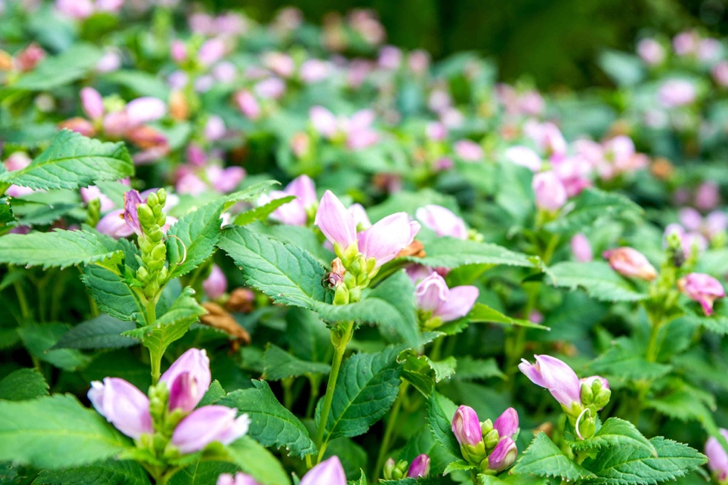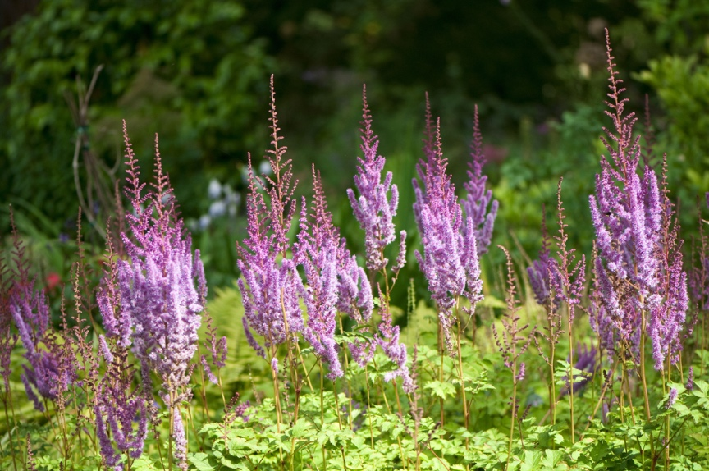

Hosta, blue-green, 2-3ft Bugleweed (Ajuga, non-invasive), white to pink, groundcover, varigated 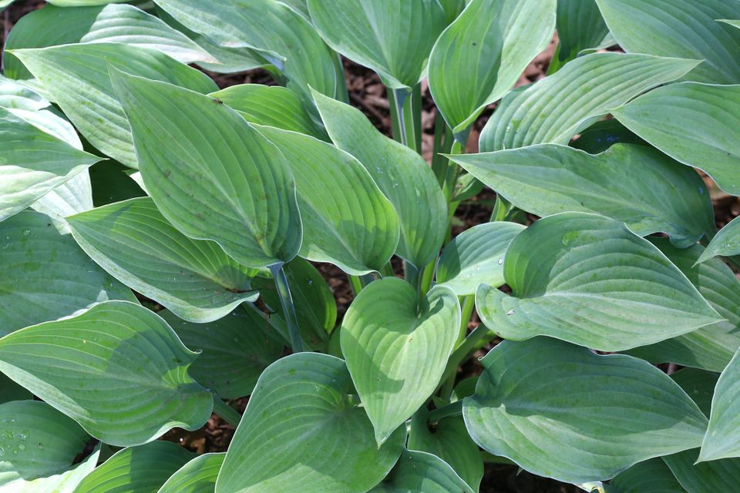 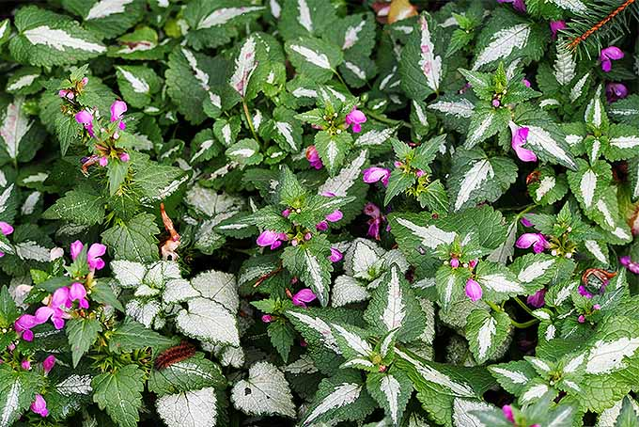
*Plants are from my garden so they will vary in size. I can clean the roots to avoid any tag-alongs. Best time for digging would be early June generally, but later in the summer is fine too.

